Bio-magnetic Healing Practitioner Course

Hi and thanks for your enquiry about the training!

There are twelve classes in total, running completely online over a period of six months with each class taking place every second Saturday.

This course has the additional benefit of private coaching/mentoring throughout the program which essentially means that you have access to me via message, email, and when necessary phone call/video call to go over any areas you are struggling with as we move through the material, ensuring that you get all you need from the course.

The fee for the training is €1250.

This price is payable in full, or it can be broken down into 12 parts at a cost of €125 per class. If paying by the class it should be understood that all classes need to be paid for even if a class cannot be attended. In these cases, the class will be recorded and sent for viewing.

Attached is a brief itinerary of what we will cover in the training. We don’t stick rigidly to this layout, but it will give you a guideline of the course contents at least.
The training courses I hold are very practical in nature with the majority of the time devoted to guided practice in order to facilitate fluid and fluent ability in this work. All theory is of course also included in the program however.
My style of teaching is very relaxed and personal and never with any pressure or stress involved for anyone which in my experience results in the quickest learning and the best practitioners.
Since I originally began training people to become Biomagnetic practitioners I have remained true to my initial focus in supporting and coaching those interested in Biomagnetic healing to be the best they can be at this work, and to subsequently heal as many people as possible. Because of this, I hold nothing back in terms of my knowledge. I don’t profess to know everything about Biomagnetism, but what I can say is that anything I do know from my 10 plus years of experience in this area, you will know, from beginning to end - from "learning the ropes" to opening your own successful practice, and everything in between.

We will be covering the below topics:

- Scanning list and anatomical locations – the scan is by far the most important part of the Biomagnetic Therapy process. This is because if you can’t find the problem you can’t fix the problem. With this being the case, I tend to place a large emphasis on getting the scan right.

- Points/Placements – being able to go through the entire body from head to toe with a magnet in hand is essential to nailing this technique correctly, so the initial classes are about getting the scanning basics concreted so everyone is on the same page in terms of knowing the points and placements.

- Biomagnetic Healing basics – we focus on the basics on the first day just to make sure everyone has a proper grasp of the fundamentals. What I mean by this is how to place the magnets correctly for the purposes of the scan and treatment, how and why the leg is contracting etc. Understanding the fundamentals of the therapy is important and shouldn’t be overlooked.

- Q&A – the questions and answers part of each class function organically throughout the day. Because the training is very relaxed and informal, any questions can be asked at any stage of the classes with me answering as we go which in my experience works best for learning.

- Bioenergetics Basics/Theory – We will go over the Bioenergetic process in detail to make sure all understand it. To do this I will give an easy-to-understand explanation of Bio-energetics, with any additional complex explanations given in written form. This is so you are capable of explaining what Bioenergetics is and how it essentially works. This understanding is vital in terms of articulating yourself as a practitioner.

- Bioenergetics Practice – Energetic scanning from head to toe. This needs to be practiced in class over and over again to gain fluidity. In my experience it is better to do this one learner at a time with the remaining learners observing and learning from each other with Q&A as we go.

- Tele-Bioenergetics – practicing distance healing work to get it right and to gain confidence with treating clients in distant locations. This will involve surrogacy, so each of you will need to ask permission from a friend or family member (or client) to allow you to treat them from Ireland through the surrogate.

- Surrogacy Safety – How to work safely and effectively with a surrogate.

- Energetic Hygiene – How to protect yourself and your clients while working distantly.

- Transference – Energetic cross contamination and how to avoid it.

Additional topics we will cover on the training will include:

- The Role of Intention – How intention works and its role in Bioenergetics.

- Interference – The issue of interference and how to avoid it.

- Hygiene protocols – How to protect yourself and your clients correctly from cross contamination

- Basic Clinical Setup – Essential items/equipment and how to set up your clinical space correctly from the perspective of BMP specifically

- Client Intake – Induction forms etc

- Initial Consultation - How to work with a new client.

- Your Personal Practitioner Intro – Creating your own introduction for new clients and how this will increase your client base significantly

- Handling Difficult Clients – How to handle difficult clients what to say and what not to

- Referrals – How to get referrals without being salesy

- De-Briefing – Correct process for de-briefing your client

- Do’s and Don’ts – How to avoid making mistakes that will jeopardize your work and your reputation.

- Diagnosis – Protecting yourself and your clients from a diagnostic point of view.

- Handling Difficult Cases – How to work with heavy illnesses both physical and emotional

- Practitioner Joint Effort – How the community of BMP practitioners matters and how we can all serve each other for the betterment of all

- Emotional Release – How to successfully work with clients to release the many emotional issues effecting those who come to your practice.

- Addressing complex issues - such as endocrine disorders, detox pathways, lymphatic system etc

- Family and Close Clients – How to work effectively with those closest to us and how to avoid entanglement issues.

- Trouble Shooting Your Work – How to self-critic for constant improvement of your work and the results of your clients.

- Pitfalls – Avoiding dangerous pitfalls in your clinic.

- Psychological Issues – How to work successfully with psychological reversal issues and inhibiting beliefs.

- Esoteric Issues – Handling non-physical issues.

- Re-Cap Theory and Practice – Discussing and clarifying the theory and practice covered in the workshops.

- Final Q&A – Clarifying any outstanding questions from the training.

- Holistic Practice Business Advice – If required.

- Certification…

The philosophy of practically orientated training

Did you know that there are people around the world (indigenous South American villagers for example) who successfully perform Biomagnetic healing every day? Did you know that most of them can neither read nor write? Did you also know that these people have just as much (sometimes more) success as Biomagnetic practitioners as anyone else who performs the therapy in other areas of the world? These very capable practitioners have little-to-no understanding of the theory behind how Biomagnetism works. They have no fancy terminology for what they do, no special equipment, and no pieces of paper to verify their ability. Yet they are no less successful at getting results for the people they treat. How is this possible? Well, its because Biomagnetic Healing first and foremost is a skill.

To learn any skill correctly, it needs to be thought to you through the processes of listening, observing, and doing. Not reading, writing, and reciting theoretical information. Instead, learning a skill requires consistent practical hands-on direction to build your confidence and ability. The lack of such practical skill-based-instruction is the reason why most students who attend the various Biomagnetic courses available around the world (both in-person and online) more often than not don’t know how to perform it properly after completion of their training. It is also why they don’t feel confident as Biomagnetic practitioners, despite being fully certified as such. It is also why most students feel the need to repeat Biomagnetic training courses over and over again. There is in fact never a need to leave Biomagnetic training lacking in skill or competence, and there is never a reason to repeat training when it is taught correctly.

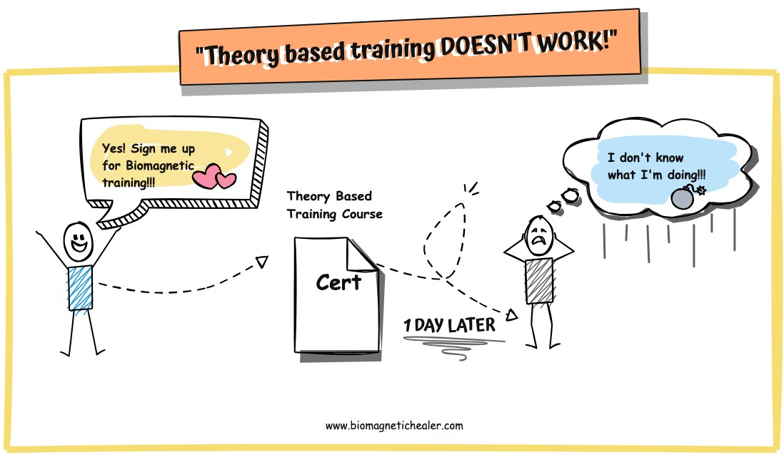

Here’s the problem – Biomagnetic training the world over is 80-90% theory and 10-20% practice, when in reality it needs to be the other way around. On this course we take a completely different approach. We’ve taken the usual theory-first, skill-second (or never) training structure and flipped it on its head. Why? Because as mentioned, Biomagnetic Healing is a skill, and if you want to learn how to become skilled at performing it, it needs to be taught to you as a skill. So, we teach the skill first, and the theory later – and we don’t get to bogged down with the theory side of things either. With us, the emphasis is firmly placed on learning how be a skilled practitioner, with all the necessary theory added in as we go in a simple and easy to understand way. You will have just as much theoretical understanding as anyone else by the end of the training, but you will have absorbed it almost as a side-effect of learning the skill. This not only allows more focus and attention to be placed primarily on developing fluid skill and ability, but it also tends to lead to an increased comprehension of the theory, which actually results in you retaining the information that you learn which in the end makes you a far better practitioner.

Our thought process when it comes to creating the best Biomagnetic Healers goes something like this – Spend the majority of our time learning the skill. Spend the remainder of our time understanding how it all works – while continuing to perfect the skill.

Why do we do it this way? Because if we learn the theory first, we only have the remaining time in order to squeeze in the skill – with very little time left to perfect it. In short, you leave without getting what you actually came to for – which for most people is the ability to actually work as a Biomagnetic Practitioner. Conversely, if we learn the skill first, we can spend the remaining time learning how it all works, while still being able to practice and perfect the skill and trouble-shooting any of your questions and helping you to iron out any wrinkles that crop up along the way. So, in the end, instead of walking away with a head full of theory and very little ability to actually perform the skill you came to learn how to perform, you walk away as a highly skilled and professional practitioner, ready and able to start work as a Biomagnetic Healer immediately after your training is complete.

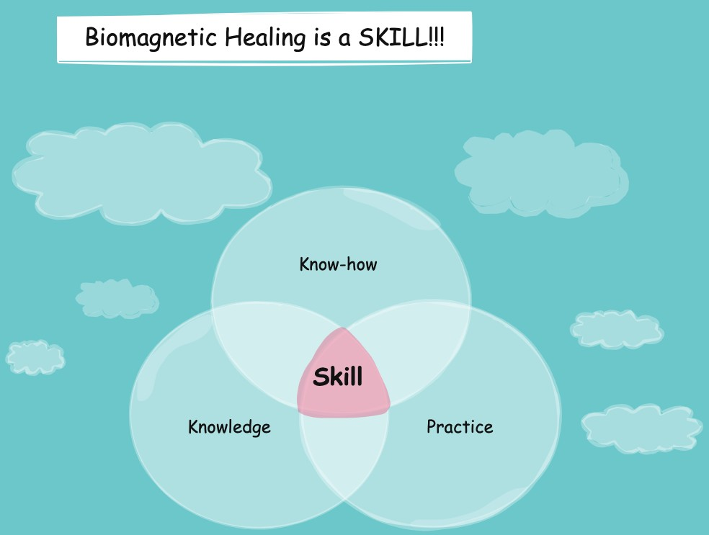

Note: There is also the option for private coaching/training available for those who prefer to take the training alone rather than as part of a group.

